QR Camera Scavenger Hunt

Find a partner, scan code and do the task. Mark off below and give it a thumbs up or Thumbs Down
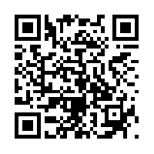

Your Need a Partner, Scan this code and complete the Task, then Check it off and say if it is a thumbs up or thumbs down
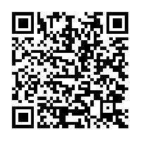

Scan this code and complete the task, Put your answer in this box
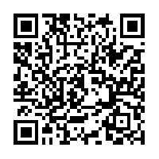

Scan this code and complete the task, then check it off and give it a Thumbs up or thumbs down
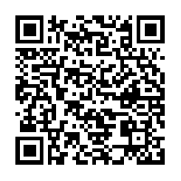
By ____________________________________________________________________________________

