Garretson School District 49-4

Web Link

Data Entry (**Requisition Entry**) Instructions

Web Link Address: <https://sui.garretson.k12.sd.us>

(shortcut along the left of the Garretson Website and you have a star app on your ipad called requisitions.)

*\*\*Note: Before completing on-line requisitions for a new school year, complete an on-line order at* [*www.schoolspecialtyonline.com*](http://www.schoolspecialtyonline.com) *for any School Specialty items you are requesting. See attached instructions for School Specialty Online.*

**Data Entry (Requisitions)**

The Data Entry option is used to enter requisitions. Once a requisition is entered and saved, the requisition must be submitted for approval. The Requisition Entry option can also used to edit (and resubmit), cancel, or delete rejected requisitions.

Select the **Data Entry** menu and then **Requisition Entry**:

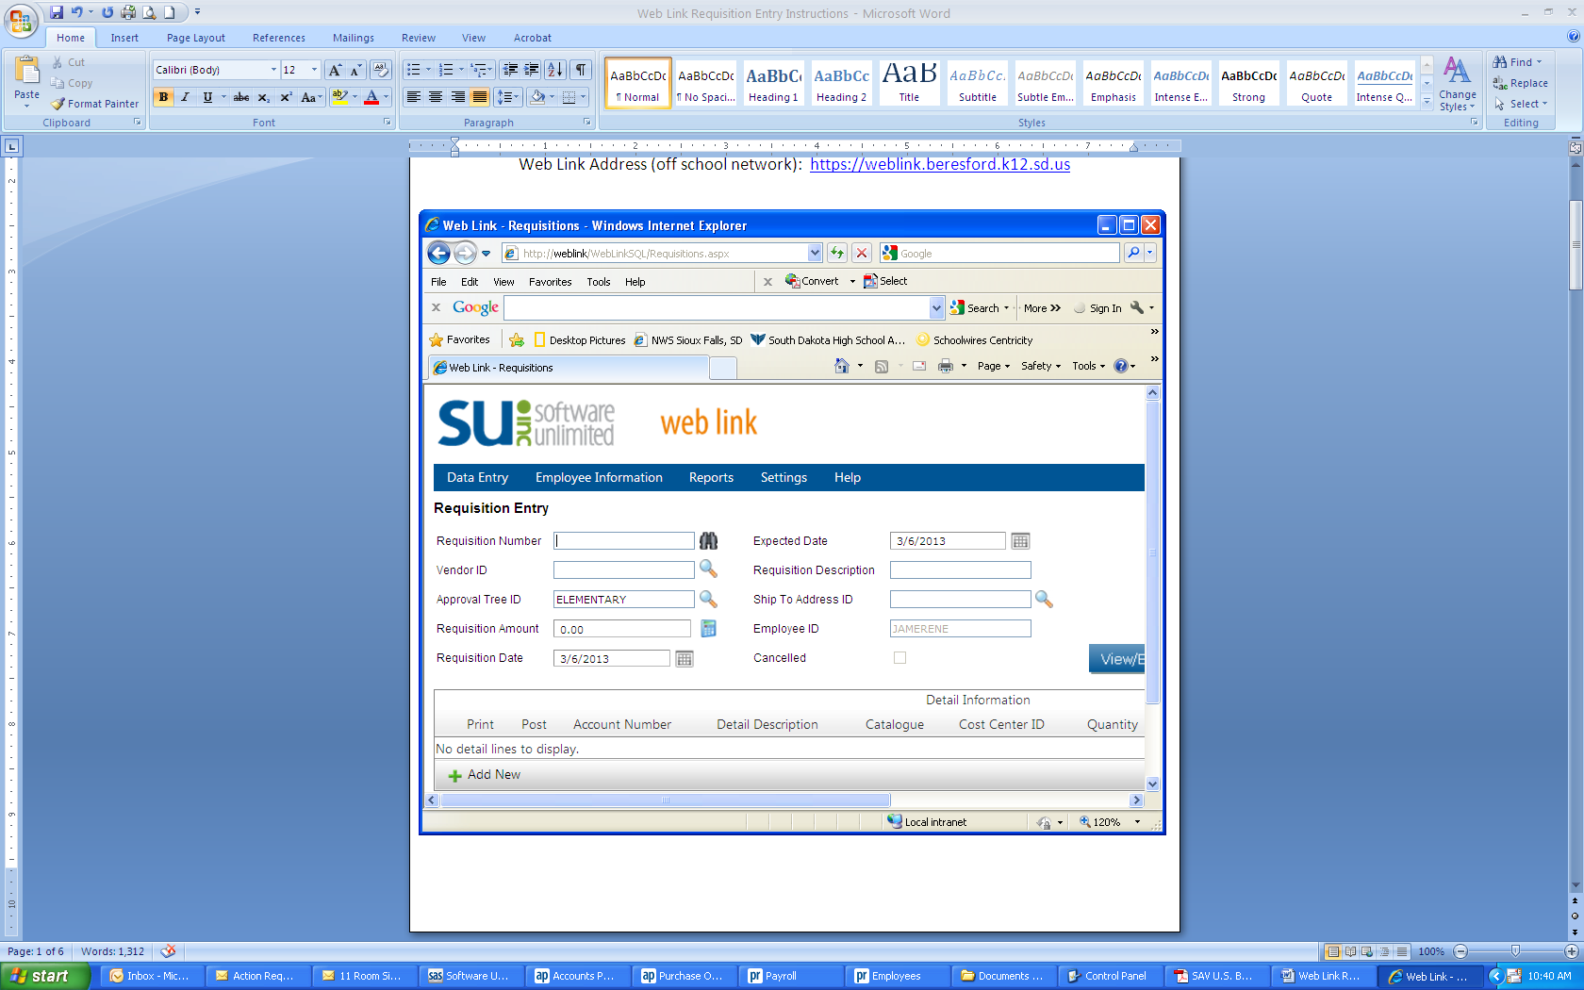

Magnifying Glass Icon

1. **Requisition Num**: required, but will be auto-assigned when you save your requisition.
2. **Vendor ID**: required.

* Click on the **magnifying glass icon** to search for the vendor.
* To narrow the search and find the vendor, **type** the first few letters of the vendor in the **Vendor Name box**; then click on the Vendor Name **filter icon** (looks like a funnel). {The best filter options are “Contains” or “Starts With”}
* When you click on the **filter icon**, a list will appear with the results that match your search criteria. **Double click** on the vendor, or click on the vendor name and then the green arrow to select and populate that vendor into the Vendor ID field.
* If the vendor you wish to use is not listed, it can be added as a new vendor. Call or e-mail Kyla (594-3451 or kyla.meyer@K12.sd.us ). You will need to provide a complete vendor name, address, and phone and fax numbers. You will be notified as soon as the vendor has been added.

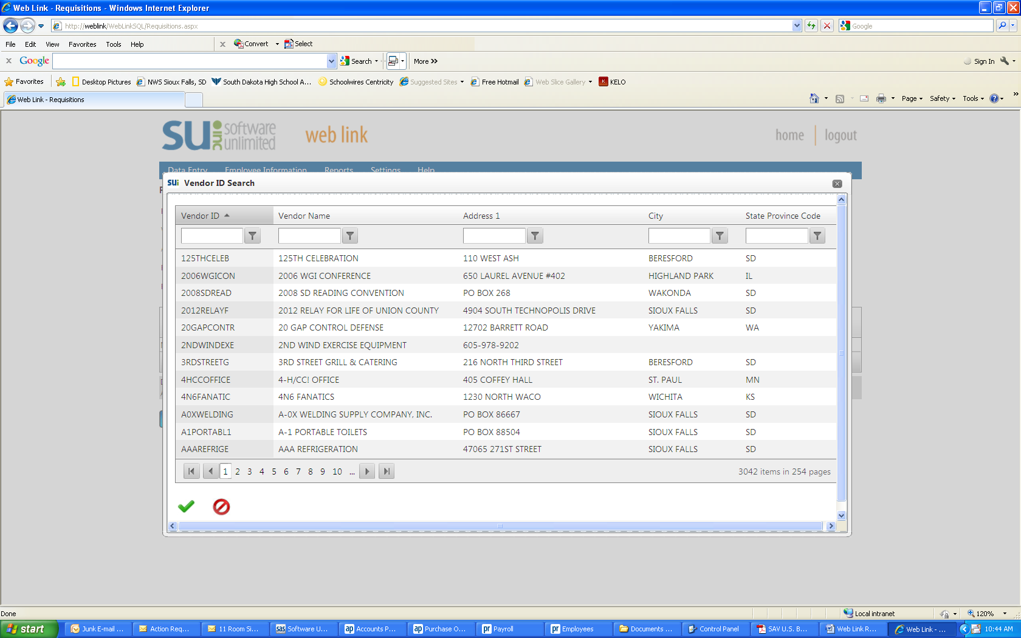

Filter Icon

1. **Approval Tree ID**: required. The Approval Tree ID designates the route your requisition will take through the approval process. The Approval Tree ID defaults to the building or department you are assigned to. Should you need to change to another Approval Tree ID, click on the magnifying glass icon and select the appropriate Approval Tree ID.

* ATHSACTS – Athletics/Activities – for coaches and advisors who are making requisitions for general fund or capital outlay items for a **sport** or other **co-curricular activity**. (approval by Activities Director)
* ELEMENTARY – Elementary – for **elementary** teachers who are making requisitions for general fund or capital outlay items for elementary instruction. (approval by Elementary Principal)
* HIGHSCHOOL – High School - for **high school** teachers who are making requisitions for general fund or capital outlay items for high school instruction. (approval by High School Principal)
* MDLSCHOOL – Middle School - for **middle school** teachers who are making requisitions for general fund or capital outlay items for middle school instruction. (approval by Middle School Principal)
* TECHNOLOGY – Technology – for employees who are making requisitions for **technology items**. (approval by Tech Coordinator)
* TRANSPORT – Transportation – for **transportation supervisor’s use only**. (approval by Business Office)
* CENTRALOFFICE – Food Service (approval by Business Office)
* TRUSTAGNCY – Trust & Agency – for coaches, advisors, and staff who monitor or supervise an **agency account**. Ex. **Girls Basketball, FFA, Mentors & Tutors**. (approval by Business Office)

1. **Requisition Amt**: required. It is not necessary to enter an amount. This field automatically calculates as you add detail lines. (If the auto-calculate does not work on your computer, you can click on the calculator icon at any time to see the requisition amount for the items have added to that point.)

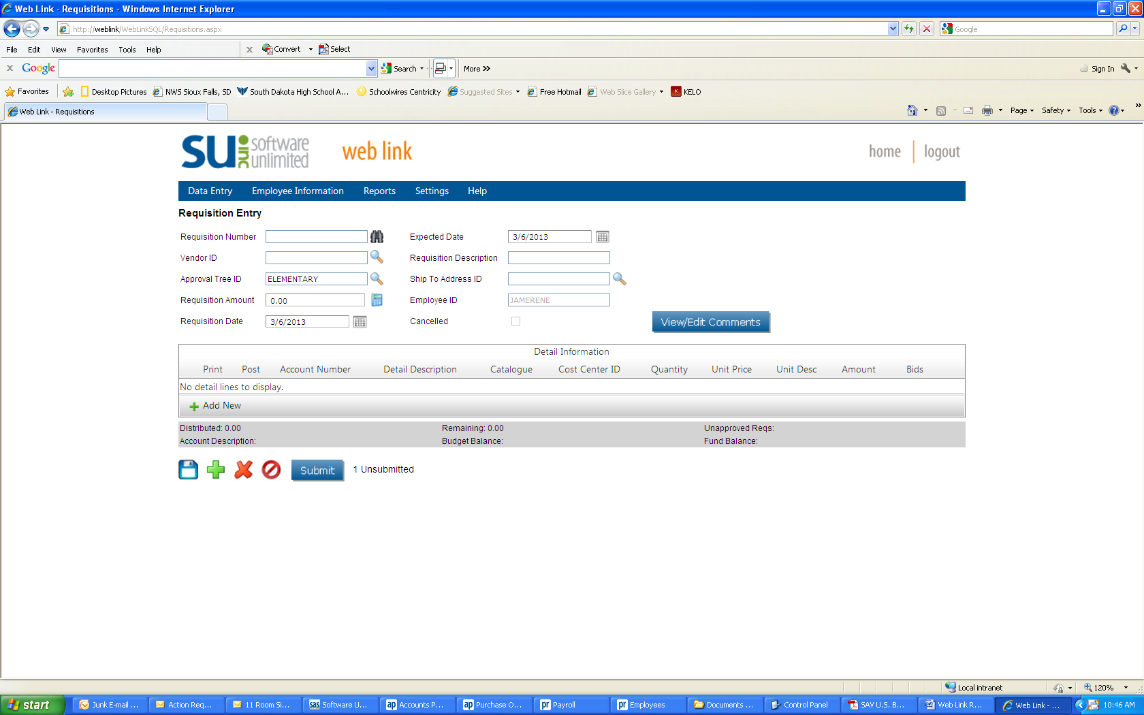

Calculator Icon

1. **Requisition Date**: required.

* Enter the **current date** if the requisition is for the **current** school year.
* Enter **7/1 + the year** if the requisition is for the **next** school year. (Example: 7/1/2013 for the 13-14 school year, 7/1/2014 for the 14-15 school year, etc.)

1. **Expected Date:** required. Use the same date as the **Requisition Date**.
2. **Requisition Description**: required. Enter a short description of your choice for your reference. Example: supplies, equipment, repairs, etc.
3. **Ship To Address ID**: required. This field auto populates based on your log in.
4. **Employee ID**: required. This field auto populates based on your log in.
5. **Detail Lines**: required.

* Click the green “**+** Add New”

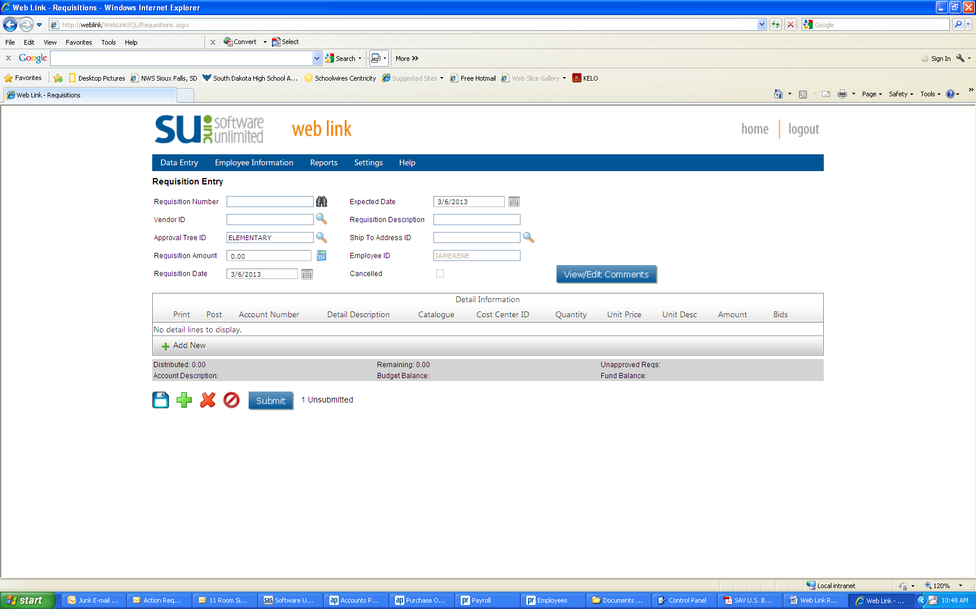

Click here to add detail line.

* **Account Number -** Click the magnifying glass icon to get a drop down list of available account numbers. Choose and double click on the appropriate account number based on the description. ***If the account number you need to use is not showing up (such as a trust and agency account number), click on the filter icon under Account Type ID.*** *Change the filter selection to “NoFilter”.* You will then have a list of all account numbers assigned to you.

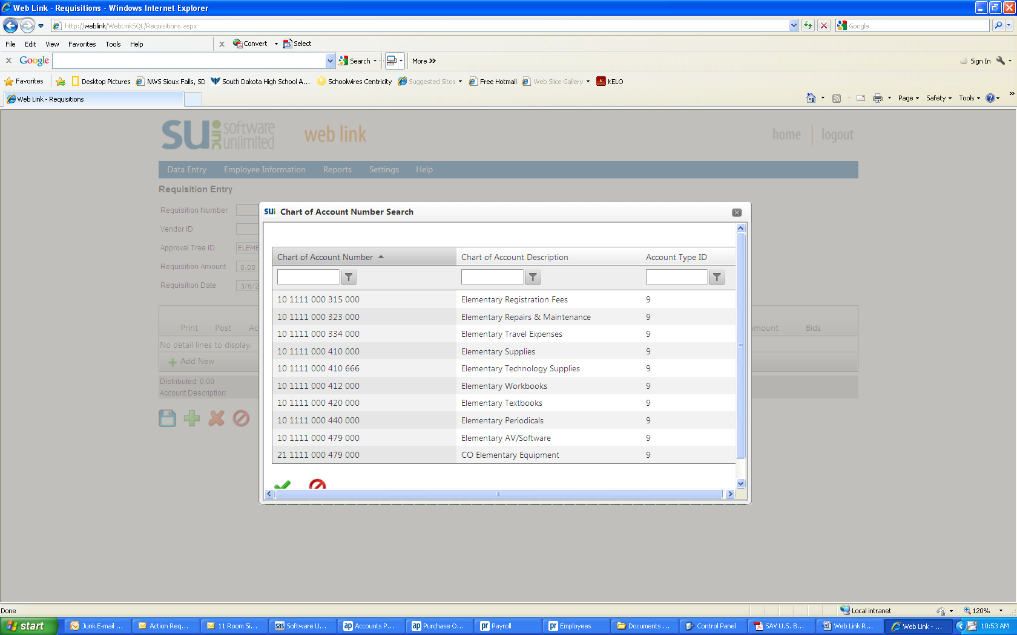

Click on the filter icon and select “NoFilter”

* **Detail Description –** Enter the specific name/description of the item requested.

This box will expand as you type, so enter details such as color, size, set of 2, etc.

* **Catalogue –** enter the **item** **number** of the item requested. **This is not the name of the catalog you are using.**
* **Cost Center ID –** not used; leave blank.
* **Quantity –** enter the quantity of the item requested.
* **Unit Price –** enter the unit price of the item requested.
* **Unit Description –** enter the unit (Example: each, case, box, etc.)
* **Detail Amount –** will auto-populate based on quantity and unit price as you tab through.
* **Split Percent –** used for shipping; currently leave blank.
* Click on the **Save** icon (3.5” floppy ☺)

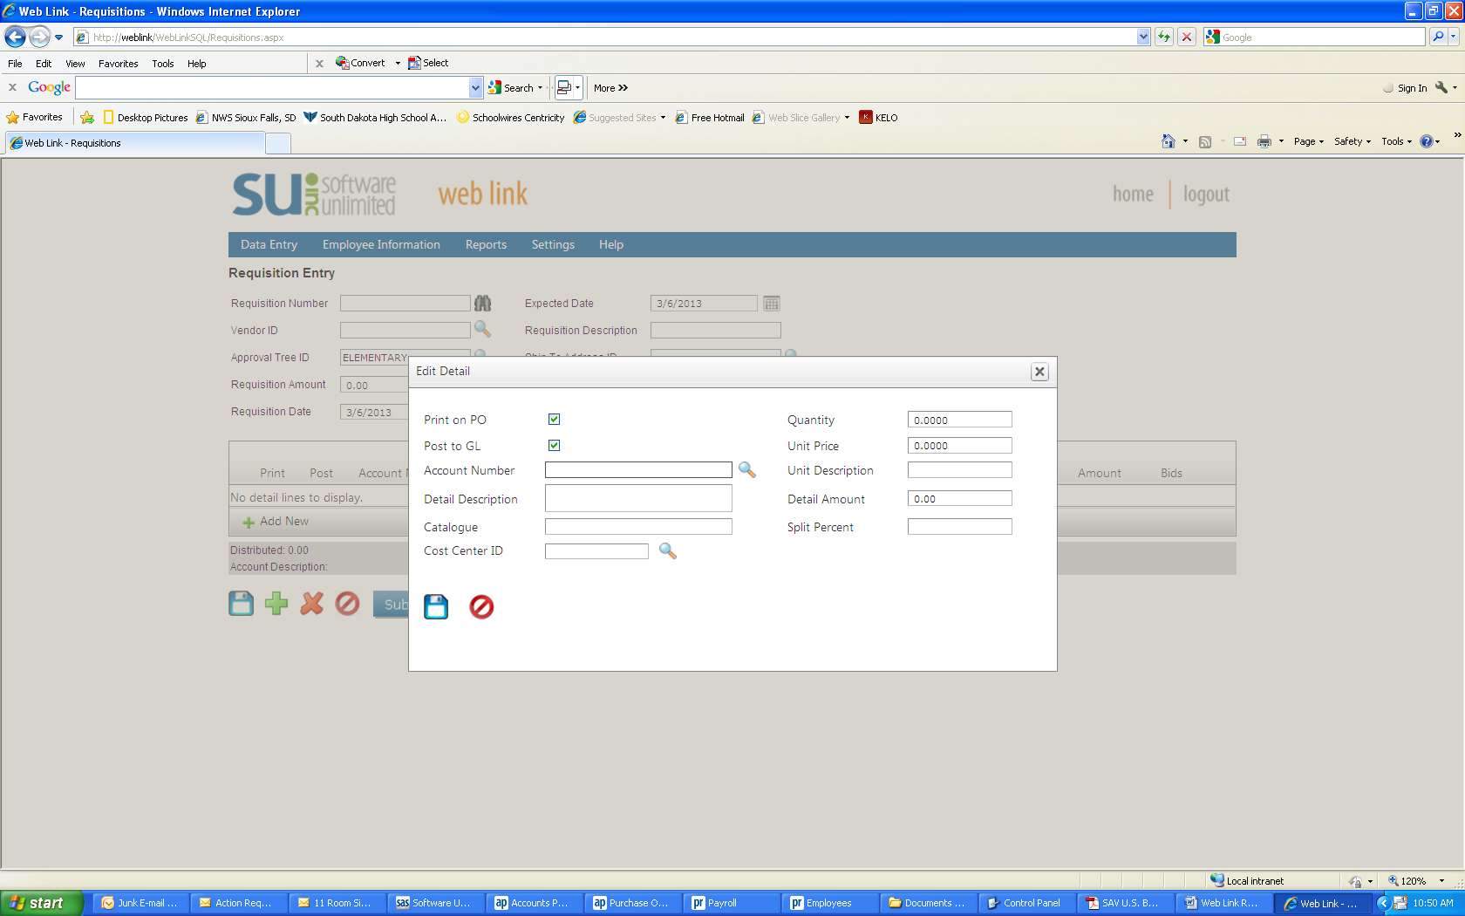

Save Icon

* Your item will be shown in the dark gray line. To add the next item, click again on “**+** Add New” and repeat the steps.
* **When you have entered all the items you are requesting from that vendor, please be sure to add SHIPPING by clicking again on “+ Add New”**
  + Enter the account number.
  + Enter the word “shipping” in the detail description.
  + If you know the exact cost of shipping, enter 1 in the **Quantity** box and enter the amount of the shipping in the **Unit Price** box.

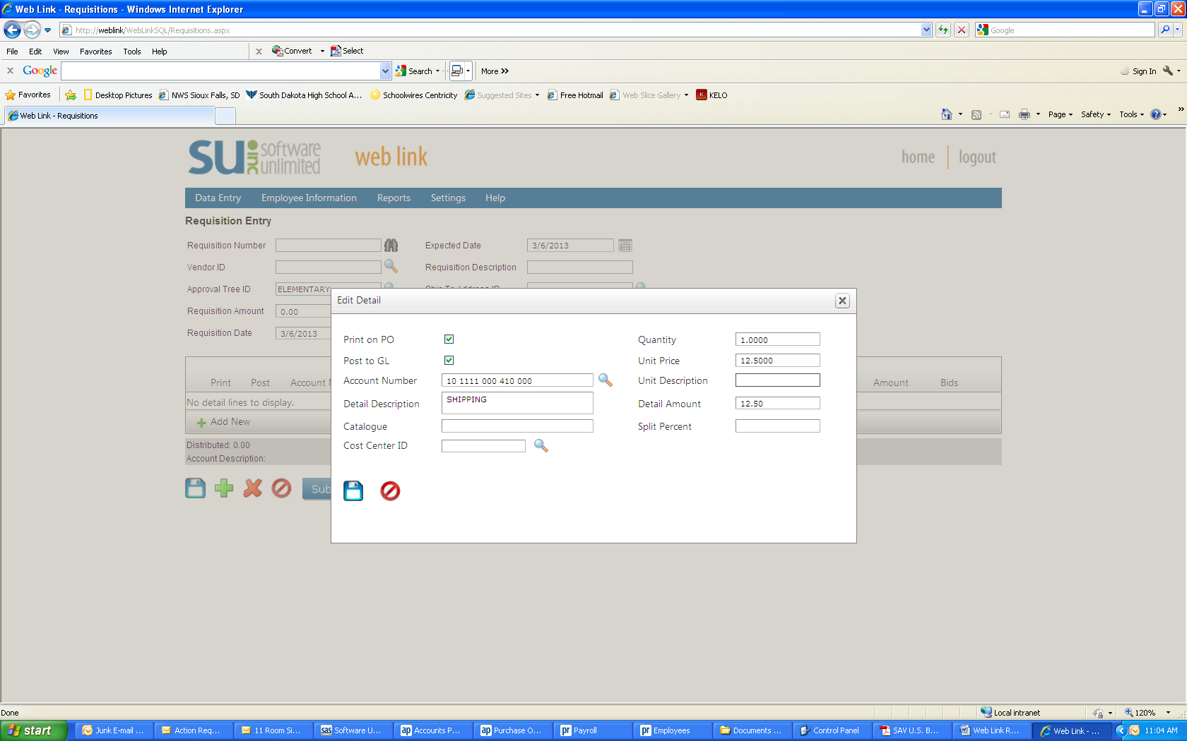

Exact Shipping Cost

* + If you do ***not*** know the exact cost of shipping, you will need to make an entry in the **Split Percent** field for estimated shipping. To do this, enter 15% followed by the requisition total. (Example: 15%48.72) Click **Save**.

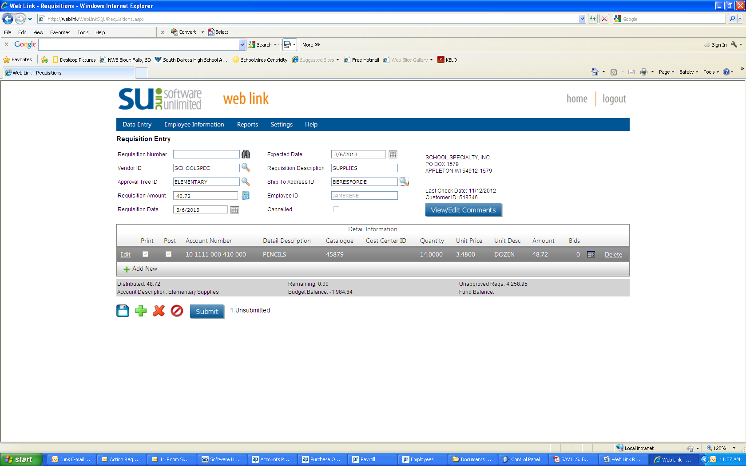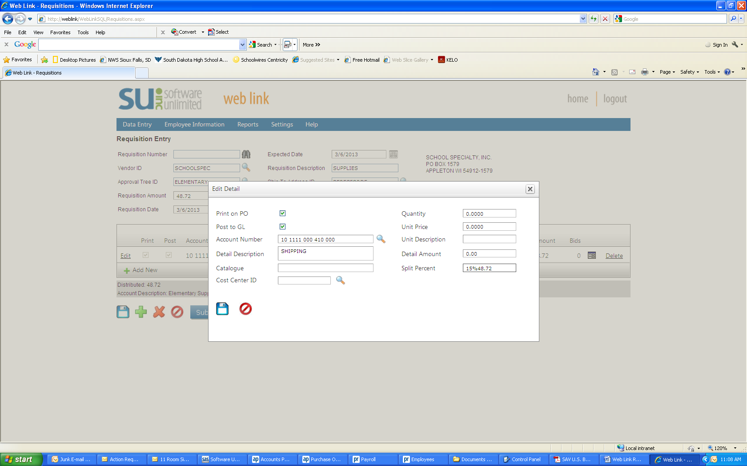

1. **View/Edit Comments:** optional.

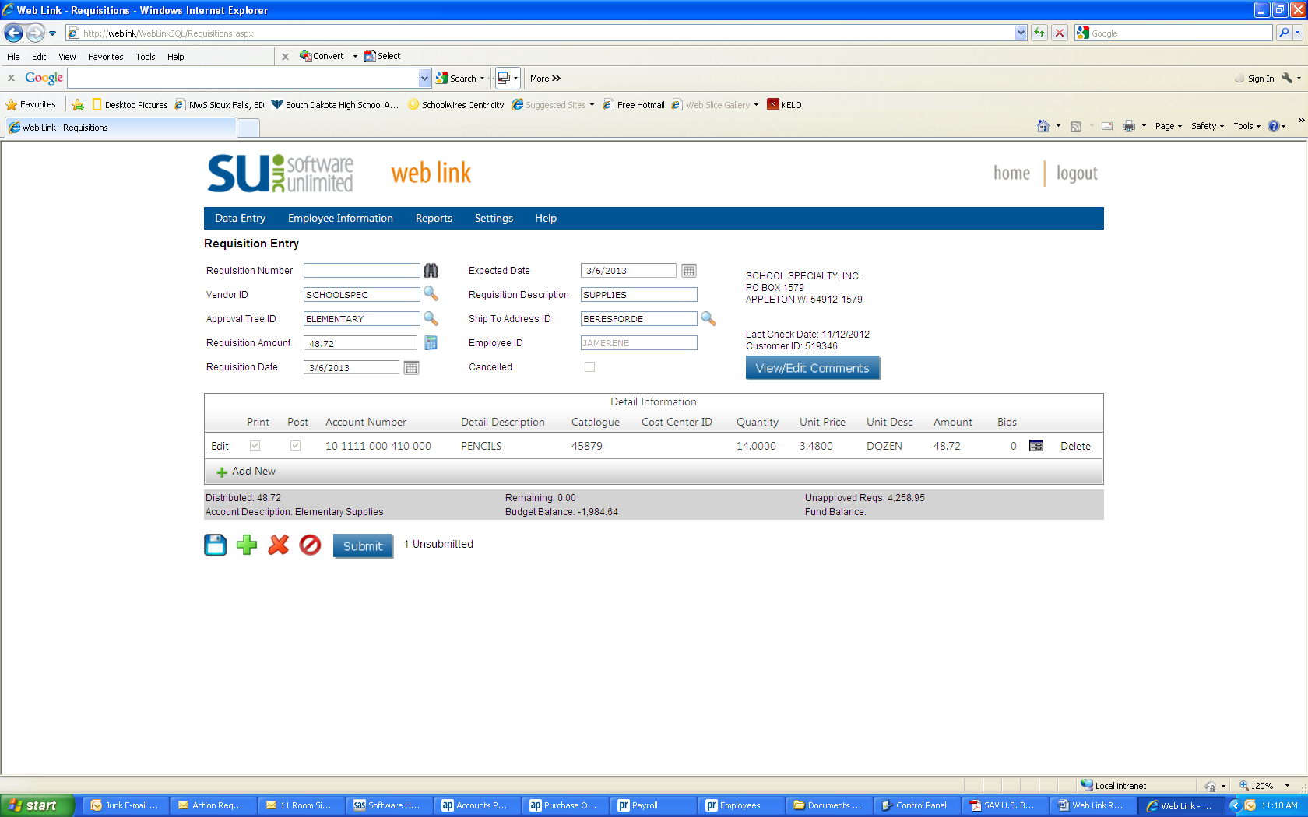

Click here to add a note

or comment.

If there is any specific information you want to include, click on **View/Edit Comments** button and then click on **Create/Edit Your Comment**. Type your message and click **OK**.

1. **Save –** if you are not ready to submit your requisition, click on the **Save** icon on the bottom left (3.5” floppy ☺). You will be able to log out of Web Link and return at a later time to finish and submit.

***To re-open a saved requisition***:

* Select the **Data Entry** menu and then **Requisition Entry**.
* Click on the magnifying icon next to the **Requisition Num** field.
* A search box will open listing your saved requisitions.
* Double click on the **Requisition Number** of the requisition you want to continue. The requisition will open in the entry screen. Make any additions or adjustments to your requisition.

1. **Important Final Step!! –** If you are ready to submit your requisition, click on the **Submit** button at the bottom. You should get a message box that states “Requisition was successfully saved and submitted”. Click on **OK.**

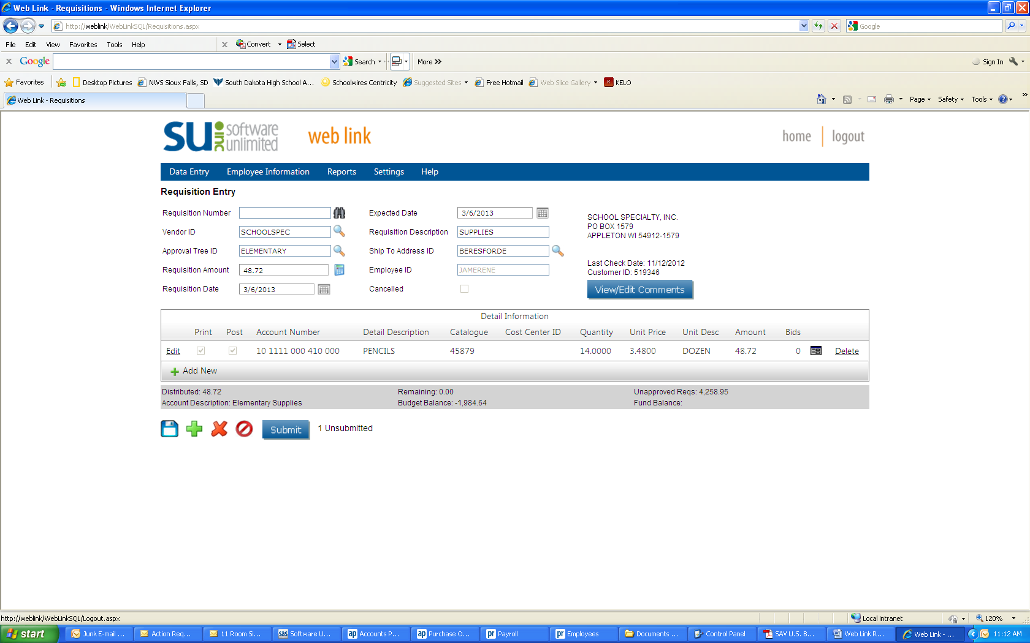

**IMPORTANT!!**

**Click here to submit.**

Repeat the steps above for each vendor that you are using. Be sure to **SUBMIT** each requisition when you are completely finished with it!!

**School Specialty Online** -

Be sure to create a requisition for your School Specialty on-line order. You do not need to list individual items, simply create one line with “On-Line Order” in the Detail Description, 1 in the Quantity field, and the total amount as the Unit Price. You do not need to add shipping for this requisition. ***If you do not create a requisition for your School Specialty on-line order, it will not be included in the budget and orders for the next school year.***

**Local Purchases –**

If you would like to request that money be budgeted for local purchases throughout the year, create a requisition with Local Purchases as the Vendor. You do not need to list individual items, simply create one line with “Local Purchases” in the Detail Description, 1 in the Quantity field, and the total amount as the Unit Price. You do not need to add shipping for this requisition.